**Example Problems**

**6603 Math Optimization**

1. 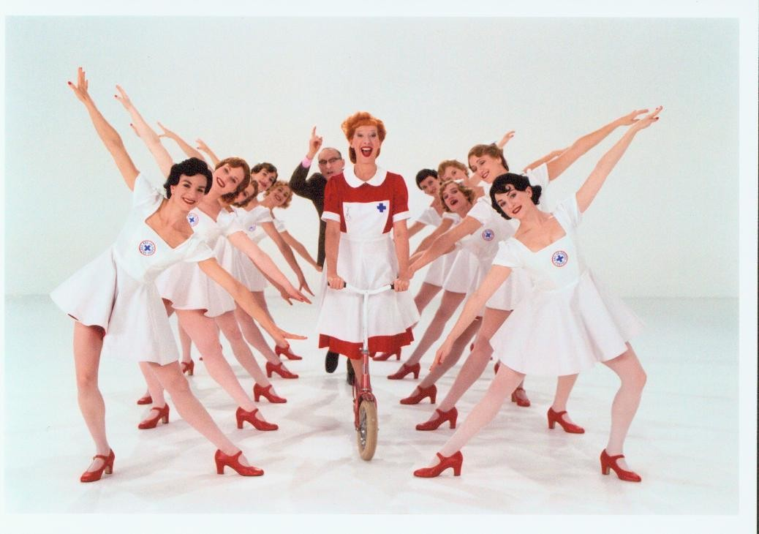Scheduling nurses to work the day shift at MetroHealth Community Hospital has become difficult in recent years owing to the extreme national shortage in nursing staff. As a recruiting inducement MetroHealth offers RNs the opportunity to work 12-hour shifts for three consecutive days in a given week, then have the remaining four days off. This means, for example, that a nurse might work the day shift Tuesday, Wednesday, and Thursday and then have off Friday through Monday. For a three-day week a registered nurse would be given base pay of $1500, but those working a Saturday or Sunday would receive an additional $300 in weekly pay. Those working Saturday AND Sunday would receive an additional $600.

MetroHealth also has the option of employing Certified Nursing Assistants (CNAs) in addition to RNs. Certified Nursing Assistants are less qualified than RNs but also work for less money and are not subject to the restrictive three-12s scheduling each week. At MetroHealth a CNA can be scheduled to work a full 12-hour shift or a partial shift, and the shifts need not be on three consecutive days. Additionally CNAs are paid only $150 per 12-hour shift (prorated if working less than 12 hours). However, there are concerns with scheduling CNAs. Regulatory guidelines require that the number of CNAs working at MetroHealth on any given shift be no more than the number of RNs also working that shift. Additionally, CNAs are not as productive as RNs. It is estimated by MetroHealth’s Director of Operations that two CNAs would generally be needed to accomplish the same amount of work on a hospital floor as one RN.

The table below shows the number of positions minimally needed during the day shift for each day of the week. The positions are stated bye the Director of Operations in terms of Registered Nurse Full-Time Equivalents (RNFTEs). That is, on Monday there is projected to be enough work at the hospital to employ at least 58 registered nurses, but 57 RNs and 2 CNAs would also meet this need.

|  |  |  |  |  |  |  |  |
| --- | --- | --- | --- | --- | --- | --- | --- |
| **Day** | **Monday** | **Tuesday** | **Wednesday** | **Thursday** | **Friday** | **Saturday** | **Sunday** |
| **Minimum RNFTEs**  **Needed** | 58 | 48 | 38 | 34 | 30 | 26 | 26 |

Formulate and solve the math optimization model that would 1) properly staff the hospital each day to at least its minimal levels while 2) minimizing the weekly nursing labor expense.

1. The Buckminster Company produces soccer balls. Buckminster must decide how many soccer balls to produce each month. It has decided to use a six-month planning horizon. The forecasted demands for the next six months are 10,000, 15,000, 30,000, 35,000, 25,000, and 10,000 respectively. Buckminster wants to meet these demands on time, knowing that it currently has 6000 soccer balls in inventory and it can use a given month’s production to help meet demand for that or future months. During each month there is enough production capacity to produce up to 30,000 soccer balls, and there is enough storage capacity to store up to 10,000 soccer balls at the end of the month. The forecasted production costs per soccer balls for the next six months are $12.50, $12.55, $12.70, $12.80, $12.85, and $12.95, respectively. The holding cost per soccer balls held in inventory at the end of any month is figured at 5% of the production cost for that month. (This includes the cost of storage and the cost of money tied up in inventory.) Formulate and solve the math optimization model which will minimize total production and inventory costs in meeting demand for the next six months.
2. Auto Company of America (ACA) produces four types of cars: subcompact, compact, intermediate, and luxury. ACA also produces trucks and vans. Vendor capacities limit total production capacity to at most 1,200,000 vehicles per year. Subcompacts and compacts are built together in a facility with a total annual capacity of 620,000 cars. Intermediate and luxury cars are produced in another facility with a capacity of 400,000 and the truck/van facility has a capacity of 275,000. ACA’s marketing strategy requires that subcompacts and compacts must constitute no more than half the product mix for the four types of cars. Profit margins, market potential, and fuel efficiencies are summarized below.

The Corporate Average Fuel Efficiency (CAFE) standards in the Energy Policy and Conservation Act require an average fleet fuel efficiency of at least 32 mpg. Formulate and solve a math optimization model to maximize profit.

|  |  |  |  |
| --- | --- | --- | --- |
| Type | Profit Margin  ($ per vehicle) | Potential Sales  (in thousands) | Fuel  Efficiency |
| Subcompact | 1500 | 600 | 40 |
| Compact | 2250 | 400 | 34 |
| Intermediate | 2500 | 300 | 25 |
| Luxury | 8000 | 225 | 24 |
| Truck | 9000 | 325 | 20 |
| Van | 2000 | 100 | 26 |

1. Ironrock Refining extracts minerals from ore mined at two different sites in Montana. Each ton of ore Type 1 contains 20% copper, 20% zinc, and 15% magnesium. Each ton of ore Type 2 contains 30% copper, 25% zinc, and 10% magnesium. Ore Type 1 costs $90 per ton to purchase from its originating mine while ore Type 2 costs $120 per ton. Ironrock would like to buy enough ore to extract at least 8 tons of copper, 6 tons of zinc, and 5 tons of magnesium in the least costly manner. Formulate and solve a math optimization model that will guide this.
2. Furnco Furniture manufactures dining tables, chairs, coffee tables, and end tables for the consumer market. For the coming year Furnco expects to earn $200 per table in profit, $160 per chair, $120 per coffee table, and $80 per end table. Furnco makes these four types of furniture using three major resources: wood, skilled labor, and unskilled labor. The table below shows how much of these three resources are needed to make each of the products as well as the total amount of these resources available in the coming year.

|  |  |  |  |
| --- | --- | --- | --- |
|  | **Wood** | **Skilled Labor** | **Unskilled Labor** |
| **Dining Tables** | 18 board feet | 1.5 hours | 4 hours |
| **Chairs** | 9 board feet | 2 hours | 2 hours |
| **Coffee Tables** | 12 board feet | 1 hours | 3 hours |
| **End Tables** | 4 board feet | 1 hours | 2 hours |
| **Total of Resource** | 60,000 board feet | 6,000 hours | 9,000 hours |

Furnco operates under the two following additional restrictions: 1) At least four chairs must be made for each table, and 2) At least two end tables must be made for each coffee table. Formulate and solve the linear programming model which will maximize profit to Furnco while staying within all the constraints in the problem.